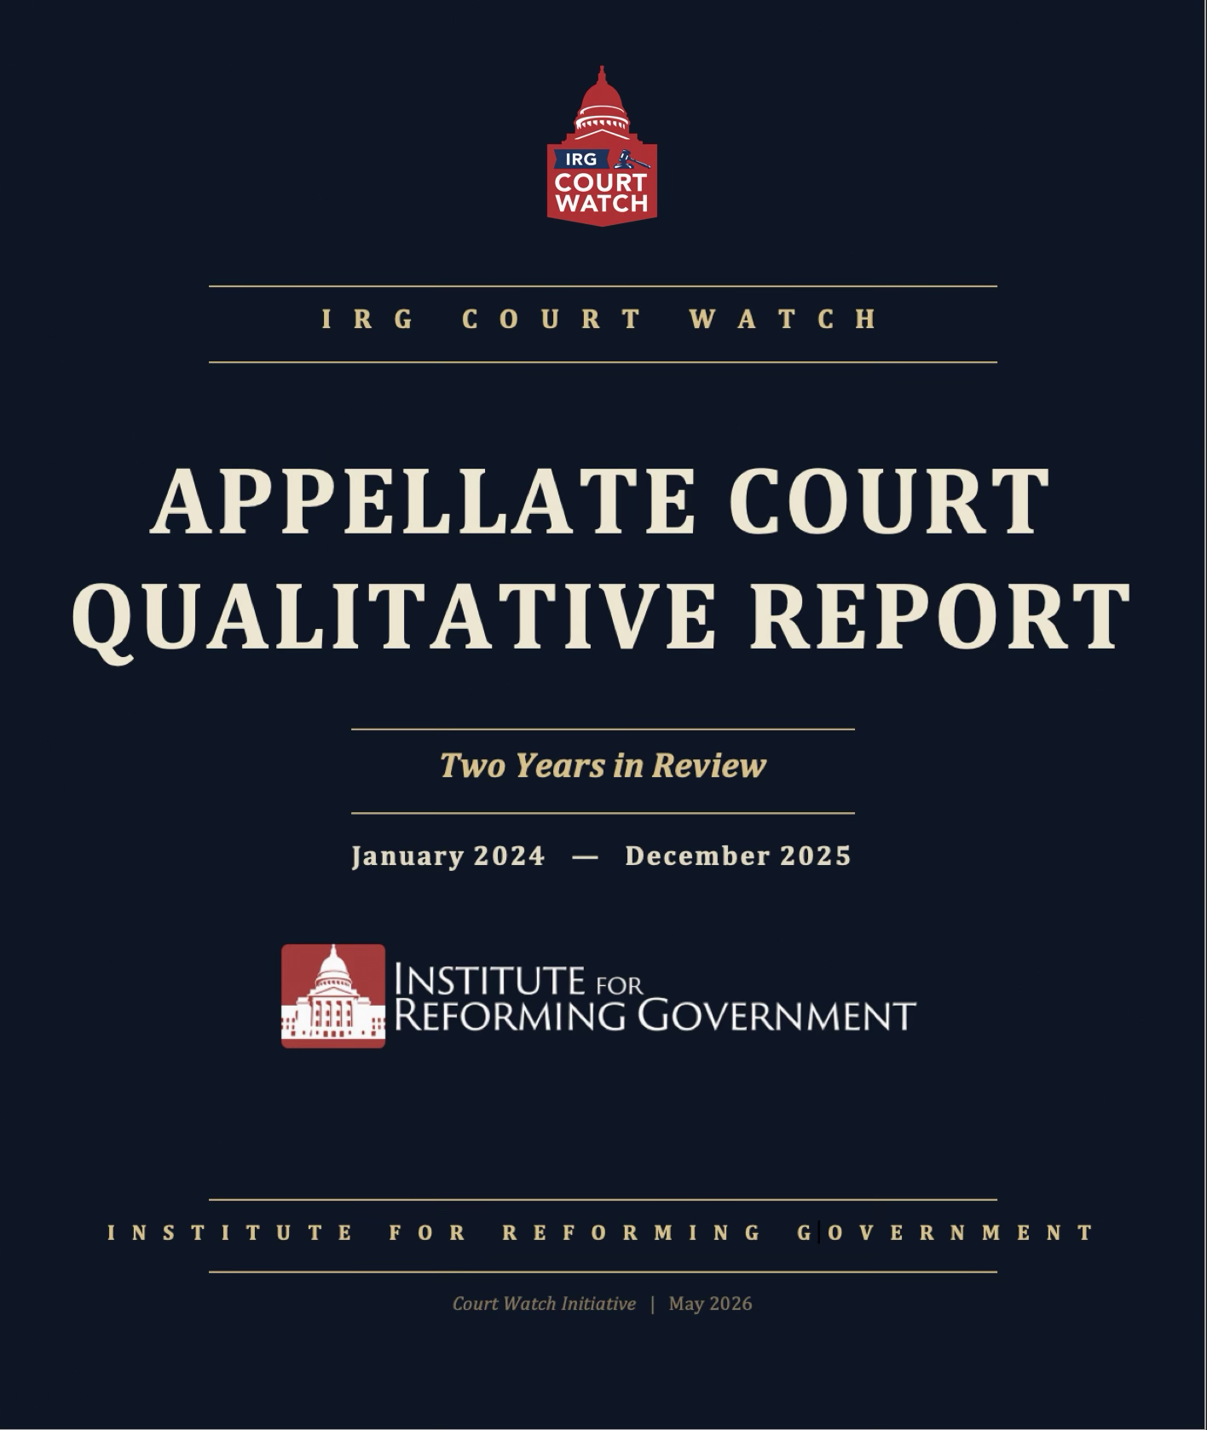

ABOUT THE IRG COURT WATCH INITIATIVE

The Institute for Reforming Government’s Court Watch initiative will track the activity of Wisconsin Courts and inform the public on their importance. From decisions on election laws, to school choice, to regulations impacting our freedoms, the courts play a crucial role in our everyday lives. Often overlooked, the courts have a quiet but giant role in nearly everything we do, yet most Wisconsinites are unaware of what they do or who even sits on the various benches.

ABOUT THE AUTHORS

JAKE CURTIS | General Counsel and Director of CIO
Jake brings a unique skill set to IRG by drawing on his years of experience as a lawyer, strategic advisor, and public official to navigate the intersection of law and policy. Throughout his career he has focused on government relations matters for both public and private sector clients, representing dozens of local units of government and handling administrative matters before WERC, DWD, ETF, DNR, DFI, DATCP and DPI. Jake is a graduate of the University of Wisconsin – Eau Claire, B.A., summa cum laude, 2005, the University of Wisconsin Law School, cum laude, 2008, the United States Air Force, Officer Training School, 2021, and the United States Air Force, The Judge Advocate General’s Corps, 2022.

DANIEL SUHR | Adjunct Legal Fellow
Suhr is an adjunct legal fellow at IRG. A former policy director for Wisconsin Governor Scott Walker, he’s also an attorney with the Center for American Rights, a nonprofit law firm that holds powerful institutions accountable to the public. A graduate of Marquette, Marquette Law, Georgetown Law, and the University of Missouri, he lives in the Milwaukee area with his family, where they’re active in their church and scouts.

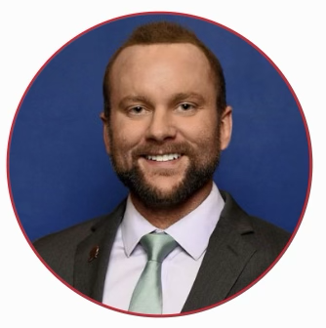
KEVIN M. ZIELINSKI | Associate Counsel for Legal Reform & Oversight
Kevin is an Illinois-licensed attorney and serves as Associate Counsel for Legal Reform & Oversight at the Institute for Reforming Government. His work advances IRG’s mission to promote accountable, limited, and effective governance. Kevin earned his Juris Doctor from Southern Illinois University School of Law, where he served as President of the Federalist Society and received a CALI Award in Advanced Constitutional Law. He also holds a Bachelor of Science in Molecular and Cell Biology from the University of Illinois at Urbana-Champaign. He currently serves as a Clinical Associate Professor at Southern Illinois University Carbondale, where he teaches Business Law.

Table of Contents
EXECUTIVE SUMMARY 4
KEY TAKEAWAYS & STRUCTURAL INSIGHTS 6
WHY THE APPELLATE COURT REPORT IS QUALITATIVE 8
ANALYTICAL FRAMEWORK - SIX DIMENSIONS 9
DISTRICT I — MILWAUKEE 11
DISTRICT II — WAUKESHA 15
DISTRICT III — WAUSAU 21
DISTRICT IV — MADISON 25
SUPREME COURT INTERACTIONS 28
LOOKING AHEAD 29
APPENDIX I: OPINIONS ANALYZED 30
District I — Milwaukee (15 opinions) 31
District II (Waukesha) 32
District III (Wausau) 33
District IV (Madison) 34
APPENDIX II: APPELLATE COURT REFERENCE GUIDE 35

EXECUTIVE SUMMARY
The Wisconsin Court of Appeals is the workhorse of the state’s judiciary. It resolves all appeals that never reach the Supreme Court (which is the vast majority of appeals). Its published opinions establish binding precedent throughout Wisconsin, dictating the interpretation of legislative statutes, outlining the boundaries of administrative agency authority, and defining the scope of constitutional protections for millions of citizens. Despite its profound influence on the trajectory of Wisconsin law, the Court of Appeals is frequently overshadowed by the high-profile ideological battles that characterize the Wisconsin Supreme Court.
Yet until now, no organization has attempted a systematic, opinion-by-opinion review of the court’s work. This report changes that.
The Institute for Reforming Government reviewed every published opinion issued by the Wisconsin Court of Appeals between January 2024 and December 2025—113 opinions across all four appellate districts. Each opinion was evaluated on six dimensions of judicial reasoning: fidelity to binding precedent, respect for legislative authority and constitutional boundaries, adherence to textualist and originalist methods of interpretation, judicial restraint, protection of individual liberty, and quality of legal craft and clarity. The analysis covers 16 judges sitting in Districts I through IV.
PARAMETER | DESCRIPTION
Evaluation Period | January 1, 2024, through December 31, 2025.
Scope | All published three-judge panel opinions issued during this window, plus unpublished opinions containing dissents.
Opinions Reviewed | 113 published opinions across all four districts.  Subject-matter coverage: criminal procedure, administrative law, statutory interpretation, constitutional law, election administration, property, contract, family law, and other areas.
Judges Evaluated | 16 appellate judges across four districts:  • District I — Milwaukee  • District II — Waukesha  • District III — Wausau  • District IV — Madison
What We Found
The Wisconsin Court of Appeals is, for the most part, a competent and professional institution. The overwhelming majority of published opinions across all four districts reflect sound legal reasoning, faithful application of binding Supreme Court precedent, and appropriate restraint. Most three-judge panels reached unanimous decisions, and the quality of written analysis was generally consistent within and across districts.

That said, several important patterns emerged from the analysis:
District II (Waukesha) produced the most significant internal divisions. Judge Lisa Neubauer dissented in five of the district’s most consequential opinions—covering administrative law, separation of powers, election law, and employment discrimination—consistently siding against the majority position on questions involving legislative authority, agency deference, and statutory interpretation. In several of these cases, the Wisconsin Supreme Court subsequently reversed the Court of Appeals majority, sometimes unanimously. Neubauer’s dissent pattern is the most distinct voting record of any judge in the four-district system.

District III (Wausau) was the most cohesive. Judges Stark, Hruz, and Gill produced no dissents during the entire evaluation period. Their opinions reflect consistent methodology and a shared approach to precedent and statutory interpretation.

District IV (Madison) was fully unanimous but drew Supreme Court scrutiny. All five District IV judges agreed on every published opinion, but the Supreme Court reversed the district in State v. Ramirez (5-2) on a speedy trial question and signaled disagreement with the district’s approach in Hubbard v. Neuman, where Justices Ziegler and Grassl Bradley dissented from the Court’s affirmance.

District I (Milwaukee) had the smallest published docket and produced one notable dissent: Chief Judge White’s dissent in Children’s Hospital v. Wauwatosa, where she departed from the majority’s textualist analysis of a property tax exemption statute.

Structural Concerns
Beyond the individual opinions, the review identified structural features of the Court of Appeals that affect the quality and consistency of Wisconsin appellate justice. As IRG’s prior research on judicial reform has documented, the current system raises significant concerns:
Geographic case concentration creates uneven dockets. District I handles a disproportionate share of criminal and commercial appeals originating in Milwaukee County. District IV handles the state’s most significant separation-of-powers and administrative law disputes because state agencies are headquartered in Dane County. These geographic realities mean that different districts develop expertise—and case law—in fundamentally different areas of law. These case concentrations also give different districts disproportionate influence over certain areas of law.
The absence of statewide panel randomization invites forum shopping. Unlike the federal circuit courts, where cases are randomly assigned to panels drawn from the full roster of active judges, Wisconsin appellate judges sit only within their geographic district. Litigants who understand the ideological composition of each district can—and do—structure their filings to land in the district most favorable to their position.
The first-to-publish rule creates a race to set statewide precedent. Because one district’s published opinion binds all other districts, a panel that publishes first on a novel question effectively sets the law for the entire state. This creates a perverse incentive to rush publication when similar appeals are pending in multiple districts rather than engage in the kind of deliberate analysis that difficult questions deserve.

KEY TAKEAWAYS & STRUCTURAL INSIGHTS
1. The Court of Appeals Is Largely Doing Its Job. Before diagnosing the structural ailments of the appellate bench, one must acknowledge its foundational stability. The Court of Appeals is largely doing its job. Across more than one hundred published opinions spanning the evaluation period, most of the docket reflects a faithful application of binding Supreme Court precedent.
In routine matters, the sixteen jurists demonstrate competent statutory interpretation under the Kalal framework and an appropriate exercise of judicial restraint. They correct evidentiary errors, enforce pleading standards, and resolve commercial disputes with methodical precision. The machinery of justice operates as designed.

2. Meaningful Differences Emerge in the Hardest Cases. When cases involve contested questions of statutory interpretation, executive agency authority, or constitutional boundaries, this baseline unanimity shatters. Meaningful differences emerge in the hardest cases. The facade of a monolithic appellate bench falls away, revealing starkly divergent methodologies.

The most significant ideological divisions occurred in District II (Waukesha). Here, the bench regularly splintered. Presiding Judge Lisa S. Neubauer repeatedly dissented from her conservative colleagues, forging a distinct progressive jurisprudence that frequently clashed with the textualist majorities authored by Judges Mark D. Gundrum, Shelley A. Grogan, and Maria S. Lazar. These fault lines prove that the philosophical disposition of the jurist remains paramount when the text is fiercely contested.

3. District Composition Matters More Than Most People Realize. Wisconsin’s appellate architecture treats the four districts as interchangeable equivalents. This is a profound fiction. District composition matters far more than most observers realize. Because cases are tethered to the circuit courts of their origin, the four appellate districts receive fundamentally different types of cases based entirely on geography.

- District I (Milwaukee) manages a heavy urban criminal and complex commercial docket, acting as a highly selective filter for constitutional procedure.
- District II (Waukesha) serves as the doctrinal battleground for significant administrative overreach, separation of powers, and election law cases.
- District III (Wausau) dominates the jurisprudence of the heartland, with a concentrated docket of environmental, property, and municipal disputes.
- District IV (Madison), seated in the state capital, handles the state’s most significant government-structure and executive agency cases.

Cross-district comparison of judicial performance is inherently misleading without accounting for these jurisdictional realities. A judge in Wausau evaluates a fundamentally different subset of the law than a judge in Milwaukee.

4. The Supreme Court reversed District II opinions more frequently than any other district. Of the four districts, District II produced the most Supreme Court interactions during the evaluation period. The Supreme Court reversed District II opinions in WMC v. DNR, Kaul v. Legislature, Halter v. WIAA, and Oconomowoc v. Cota. In each case, Judge Neubauer had dissented from the Court of Appeals majority—a pattern warranting close attention as its composition evolves.

To the untrained eye, these reversals might suggest appellate error. Through the lens of constitutional fidelity, they signal precisely the opposite. The Supreme Court’s progressive majority approaches the law from a fundamentally different, highly activist posture compared to District II’s textualist, conservative majority. Accordingly, reversals by a 5-2 progressive majority should be considered a badge of honor—not a flaw.

When Judges Grogan, Gundrum, and Lazar faithfully applied original public meaning and refused to defer to administrative overreach, they fulfilled their constitutional oath. That the progressive Supreme Court subsequently reversed their rulings reflects the high court’s ideological drift, not the appellate panel’s legal acumen. Conversely, Judge Neubauer’s repeated alignment with the progressive Supreme Court majority highlights an activist methodology deeply at odds with the conservative restraint required of an intermediate jurist.

5. The Court of Appeals Should Have More Flexibility to Revisit Wrongly Decided Precedent. Under the current framework, a published Court of Appeals opinion binds all four districts until the Supreme Court overrules it. If the first district to publish on a novel question gets the analysis wrong, every other district is locked into following that error. The Court of Appeals should have a mechanism to reconsider and correct its own published precedent without requiring Supreme Court intervention—analogous to the federal circuits’ en banc review

6. District IV Has Disproportionate Judges Relative to Its Caseload. District IV operates with five judges yet handles a published docket comparable in size to districts with three or four judges. This structural imbalance raises questions about resource allocation and whether the current district boundaries reflect the actual distribution of appellate workload.

7. Structural Reform Deserves Serious Consideration. The geographic concentration of case types, the absence of statewide panel randomization, and the first-to-publish binding precedent rule all create structural pressures that affect the quality and consistency of Wisconsin appellate law. These are not problems that can be solved by evaluating individual judges—they require institutional reform of the kind IRG has previously proposed in Structural Reform of Judicial Selection in Wisconsin.

8. Districts should evaluate their practices vis-à-vis their peers. From a practitioner perspective, different districts approach different parts of the judicial process differently. Some districts are more inclined to publish their opinions, while others publish more rarely. Some prefer oral argument; others shy away from it. Because some districts publish more, they may also have longer wait times to decision. Some of this may reflect the districts’ unique dockets—the criminal cases in District I, for instance, may present fewer novel questions worthy of publication than the governmental cases in District IV.

WHY THE APPELLATE COURT REPORT IS QUALITATIVE
The IRG Court Watch Supreme Court Scorecard assigns numerical ratings because the institutional role of Wisconsin's court of last resort demands it: the Supreme Court controls its own docket, shapes state constitutional doctrine, and exercises final authority over Wisconsin law. The Court of Appeals occupies a fundamentally different position—and a numerical ranking applied there would measure the wrong things and obscure the right ones.

Established in 1978 to relieve the Supreme Court's caseload, the Court of Appeals sits in four geographic districts and hears appeals from circuit courts within each district. Its primary function is error correction: determining whether the circuit court correctly applied the law. Its published opinions perform a secondary function—clarifying and developing the law within bounds set by the Supreme Court—and are binding precedent statewide until the Supreme Court overrules them.

A judge who faithfully applies binding precedent, even when personally disagreeing with it, is performing the job correctly. A judge who departs from precedent, reads words into or out of statutes, or reaches beyond the issues presented is not.

Under Wis. Stat. § 752.31, the Court of Appeals' mandate is to review for legal error, not to develop new doctrine. Appellate judges are bound, far more tightly than Supreme Court justices, by binding precedent from above. A rubric that rewards constitutional boldness punishes the very discipline the institutional role demands.

Three-judge panels obscure individual authorship. At the Supreme Court, separate writings make individual positions visible; at the Court of Appeals, dissents are rare and panels routinely issue unanimous opinions that paper over internal disagreement. A score attributed to the named author flatters its own precision.

Unlike the Supreme Court, which exercises near-total discretion over certiorari, the Court of Appeals takes every appeal properly filed and venued; its dockets are assigned, not selected. Subject-matter scoring rewards or punishes judges for the luck of the draw. Supreme Court review is rare—historically granted in fewer than ten percent of petitions, and in recent terms closer to two to four percent. Scoring judges on that thin slice of outlier cases misrepresents a much larger body of work

What readers need to know is qualitative:

- Does the judge's reasoning adhere to statutory text?
- Does it engage binding precedent faithfully?
- Does it decide only what the case requires?

The Appellate Report Card answers those questions in structured narrative profiles and case-by-case analysis.

The result is not a softer product. It is a more honest one.

ANALYTICAL FRAMEWORK - SIX DIMENSIONS

Still, the IRG Court Watch team evaluated all published opinions across six dimensions of judicial reasoning; for each opinion we asked the following questions across those six dimensions:

1. Adherence to Precedent. This dimension measures whether the opinion identifies and applies the controlling Wisconsin Supreme Court authority on the question presented. The reference points are external and verifiable: the Cook v. Cook precedent hierarchy; the existence of on-point Wisconsin Supreme Court holdings; whether contrary authority cited in the briefs was addressed or ignored. An opinion that cites controlling authority, applies it to the facts, and explains any distinctions from factually similar cases satisfies this dimension; in contrast, an opinion that omits on-point Supreme Court authority, misstates the holding of a cited case, or distinguishes binding precedent on grounds the precedent itself forecloses is unsatisfactory. Where binding precedent compels a result that the panel considers unsound, the dimension credits panels that apply the precedent and flag the issue for Supreme Court reconsideration through concurrence or certification under § 809.61.

2. Legislative Deference. This dimension measures whether the opinion treats the legislature's enacted text as the operative legal instrument. The reference points are the statutory language itself and the de novo standard of review Tetra Tech restored. An opinion satisfies this dimension when it (a) applies de novo review to agency legal interpretations rather than deferring under the great-weight or due-weight frameworks—Wisconsin's Chevron analogues—that Tetra Tech abandoned; (b) holds agencies to the procedural requirements of any rulemaking authority the legislature delegated; and (c) decides the case on the words the legislature enacted without reading additional words in or existing words out. An opinion that reflexively defers to an agency's legal interpretation, or that invokes legislative purpose to reach a result the enacted text does not support, does not satisfy this dimension.

3. Textualism and Statutory Fidelity. This dimension measures whether the opinion applies the Kalal plain-meaning framework as the Wisconsin Supreme Court requires. Kalal is not a reviewer preference; it is binding Wisconsin Supreme Court precedent that prescribes a specific analytical sequence. An opinion satisfies this dimension when it begins with the statutory language, engages statutory structure and recognized canons of construction, and reaches extrinsic sources only after a threshold finding of ambiguity. Where text is genuinely ambiguous, the opinion must apply the applicable substantive canon (e.g., rule of lenity in criminal matters, strict construction of tax exemptions) before resorting to legislative history. Opinions that skip the plain-meaning analysis, jump to legislative history without finding ambiguity, or invoke statutory purpose as a substitute for statutory text fail to follow the framework Kalal requires.

4. Judicial Restraint and Role Fidelity. This dimension measures whether the opinion decides what the parties asked the court to decide, and no more. The reference points are the question presented on appeal, the grounds briefed by the parties, and the institutional role of an intermediate appellate court under Cook v. Cook. An opinion satisfies this dimension when it resolves the case on the narrowest available ground, avoids unnecessary dicta to the disposition, and declines to reach constitutional questions where sub-constitutional grounds are adequate. Opinions that declare statutes unconstitutional when avoidance doctrine applies, create new legal tests where existing Supreme Court frameworks already govern, resolve issues the parties did not raise, or issue advisory rulings on hypothetical questions fail this dimension.

5. Individual Liberty. This dimension measures whether the opinion applies the scrutiny that the relevant constitutional provision demands. The reference points are the text of the specific constitutional protection at issue—under the United States Constitution, the Wisconsin Constitution, or both—and the established doctrinal framework governing it. An opinion satisfies this dimension when it identifies the applicable constitutional test, applies the level of scrutiny that test requires, and does not substitute a deferential posture toward government action where the Constitution requires meaningful review. This dimension does not measure outcomes. It measures whether the opinion subjected the government's conduct to the analytical scrutiny the constitutional text demands.

6. Craft and Clarity. This dimension measures whether the opinion is written so that its operative legal rule can be identified and applied by the audience that will rely on it: circuit court judges bound by the holding, practicing attorneys advising clients, and informed citizens navigating Wisconsin law. The reference point is the opinion's usability as binding precedent — a standard heightened by the publication criteria under which published Court of Appeals opinions are selected. An opinion satisfies this dimension when the holding is clearly stated, the reasoning is organized so that each step is identifiable, and the disposition follows logically from the analysis. Opinions that bury the holding in tangential discussion, contradict themselves internally, or are structured such that a reader cannot determine what rule has been established do not satisfy this dimension.

DISTRICT I — MILWAUKEE
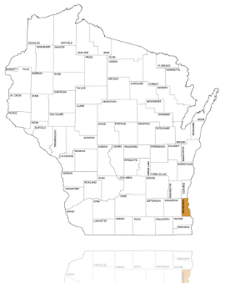
District I, headquartered in Milwaukee, is the state’s most urban appellate district. It handles appeals primarily from Milwaukee County and surrounding areas, producing a docket weighted toward criminal appeals, commercial disputes, and family law. During the evaluation period, District I produced 15 published opinions—the smallest published docket of any district.
Panel Composition
District I’s panel during the evaluation period consisted of Chief Judge Maxine A. White, Presiding Judge M. Joseph Donald, Judge Sara J. Geenen, and Judge Pedro A. Colón. The four judges rotated across three-judge panels, with most opinions decided unanimously.
Analytical Overview
District I’s published opinions during the evaluation period were competent but largely unremarkable. The small number of published cases limited the opportunity for significant doctrinal development. Most opinions involved straightforward application of established precedent to fact-specific disputes.


Judge Profiles
Judge Sara J. Geenen
District I—Milwaukee
Judge Geenen, who was elected in 2023, joined the court with a background in labor and employment law, as well as prior experience in state politics. In State v. Kenyon, Geenen navigated a complex chain of criminal law precedent—reconciling Batchelder, Cissell, Karpinski, and Lindsey—with precision and intellectual honesty. The opinion’s treatment of the trial-penalty concern was analytically sophisticated, acknowledging the structural issue without overreaching to resolve it. In State v. Adams, Geenen articulated a doctrinal framework for juvenile discovery rights, correctly applying the Kleser framework as the governing standard.


Judge M. Joseph Donald
District I—Milwaukee
Judge Donald, appointed by Evers in 2019 and serving as the Deputy Chief Judge, consistently joins well-reasoned majorities without feeling compelled to write separately, reflecting a highly restrained judicial temperament. Judge Donald participated in the majority of District I’s published opinions during the evaluation period but authored few. His endorsement record is consistent—he joined well-reasoned majorities across criminal, civil, and administrative law cases without separate writing. Donald’s analytical approach, as reflected in the opinions he joined, tracks the district’s generally competent and restrained approach to appellate review.


Judge Pedro A. Colón
District I—Milwaukee
Judge Colón, appointed by Governor Tony Evers in 2023, is a former Wisconsin state legislator (1999–2010) and the first Latino ever elected to the Wisconsin Legislature. His background includes serving on the Joint Committee on Finance and as a commissioner for the Milwaukee Metropolitan Sewerage District. Judge Colón authored several notable opinions, including the majority in Children’s Hospital v. Wauwatosa (the property tax exemption case) and Hess v. WEC (an election law case involving WEC’s application of the substantial compliance doctrine). Colón’s textualist methodology in Children’s Hospital was rigorous—he correctly applied the statutory framework and declined to expand the exemption beyond what the text supported, drawing a well-reasoned dissent from Chief Judge White.


Judge Maxine White
District I—Milwaukee
Chief Judge Maxine White, appointed by Governor Tony Evers in 2020, serves as the administrative head of the entire Court of Appeals system. Chief Judge White authored a strong opinion—Lorbiecki v. Pabst, a complex multi-issue appeal involving statutory interpretation and common law doctrine—earning the district’s highest marks for precedent fidelity and textual analysis. However, White’s dissent in Children’s Hospital v. Wauwatosa departed from the majority’s textualist approach, arguing for a broader reading of “used exclusively” in the property tax exemption statute that the majority found unsupported by the statutory text. The dissent’s central proposition—that a construction phase satisfies an “exclusive use” requirement—relied on purposivist reasoning that prioritized the statute’s perceived intent over its enacted language.

Notable Opinions
State v. J.D.B. (2025 WI App 5), rev'd, 2026 WI 5.
A published District I opinion addressing involuntary medication of adult criminal defendants found incompetent to stand trial under the Sell framework. See Sell v. United States, 539 U.S. 166, 180–81 (2003) (a court must find that "important governmental interests are at stake," that "involuntary medication will significantly further" those interests, that "involuntary medication is necessary to further those interests," and that "administration of the drugs is medically appropriate" before ordering the forced administration of psychotropic medication to render the defendant competent to stand trial). Applying that framework to a defendant charged with battery to a law enforcement officer following a mental-health crisis, the panel reversed the circuit court's involuntary medication order, concluding that none of the four Sell factors had been established and that the circuit court's findings under Wis. Stat. § 971.14(3)(dm) and (4)(b) were clearly erroneous. The Wisconsin Supreme Court reversed on review.
Lorbiecki v. Pabst (2024 WI App 33), aff'd in part, rev'd in part, 2026 WI 12.
Chief Judge White's strongest authored opinion: a complex, multi-issue appeal involving asbestos mesothelioma wrongful death under the safe place statute resolved unanimously. Affirmed liability on all grounds: circumstantial evidence of routine exposure practices sufficient, spoliation instruction within discretion, Sprinkmann's negligence properly imputed under the statute's non-delegable duty. On cross-appeal, delivered a first-impression interpretation of § 895.043(6), holding "compensatory damages recovered by the plaintiff" means total recoverable damages from all parties—not the defendant's apportioned share—nearly doubling the judgment to $13.42M. Clean textualism, strong precedent fidelity across statutory and common law doctrine, appropriate deference to jury fact-finding.
Children’s Hospital of Wisconsin v. City of Wauwatosa (2025 WI App 43).
The most analytically significant District I opinion. Colón's majority held that Family Hospital's "readying rule" applies only to fully constructed buildings in final preparation for exempt use—not to a building 14% complete at assessment. The analysis rested on § 70.11(4m)'s "used exclusively" text, the presumption against exemption, and a separation-of-powers point that exemption lines are the legislature's to draw; CHW's "absurd results" argument was rejected as conflating distinct exemptions. Chief Judge White dissented, surveying a national split and arguing that construction is an indispensable prerequisite to exempt use and should satisfy the readying rule where the completed building's exemption is undisputed.

Hess v. WEC (2024 WI App 46).
Judge Colón’s election law opinion upholding WEC’s acceptance of nomination papers with photocopying defects under the substantial compliance standard. Colón traced WEC’s authority through a clean statutory chain—§ 8.07’s rulemaking delegation to EL 2.05(5) to § 8.30(1)(a)’s discretion—and drew a precise textualist distinction between “shall” as a content mandate versus a format mandate. Read § 5.06(8) standing by its plain text, refusing to graft a candidate-only limitation the legislature never wrote—an analysis later cited approvingly by Justice R.G. Bradley’s dissent in Brown v. WEC (2025 WI 5).

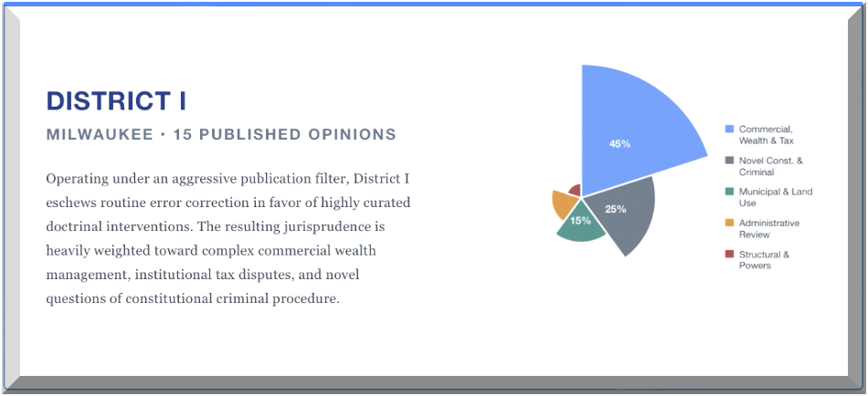

DISTRICT II — WAUKESHA
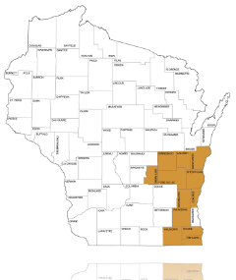
District II, headquartered in Waukesha, is the most dynamic and closely watched appellate district in Wisconsin. Covering the suburban collar counties around Milwaukee, District II produced the largest and most diverse docket of published opinions (42 opinions) during the evaluation period. It serves as the primary battleground for the state's most significant disputes regarding administrative authority, environmental regulation, and the separation of powers.
Panel Composition
District II's panel consisted of Presiding Judge Mark D. Gundrum (succeeded by Judge Lisa S. Neubauer as presiding judge in August 2025), Judge Neubauer, Judge Shelley A. Grogan, and Judge Maria Lazar. The district's opinions were generally decided by three-judge panels drawn from this four-judge roster.
The Defining Pattern: Judge Neubauer’s Dissents
The defining jurisprudential feature of District II is the pronounced and highly consistent dissent pattern of Judge Neubauer. Across the evaluation period, Neubauer filed dissents in five of the district's most consequential published opinions, arising out of five underlying controversies: WMC v. DNR, Halter v. WIAA, Oconomowoc v. Cota, Braun v. Vote.org, and the two statutory companions in the Attorney General settlement-authority litigation—Kaul v. Legislature, 2025 WI App 3 (§ 165.08), and Legislature v. Kaul, 2025 WI App 2 (§ 165.10). In each instance, Neubauer broke from the panel majority—authored by Lazar in three instances, Grogan in two, and Gundrum in one—on questions involving legislative authority, agency deference, and statutory interpretation. This pattern is critical because the Wisconsin Supreme Court, which shifted to a new majority in 2023, has repeatedly intervened to reverse District II majorities and adopt Neubauer's dissenting rationale.
In WMC v. DNR, Judge Grogan authored a majority opinion restricting the Department of Natural Resources (DNR). Grogan ruled that the agency had to promulgate formal administrative rules identifying specific quantities of "hazardous substances" before enforcing the Spills Law against PFAS contamination via the Voluntary Party Liability Exemption (VPLE) program. Neubauer dissented, arguing that the majority misread the statutory enforcement framework and unlawfully constrained the executive branch's case-by-case enforcement discretion. The Supreme Court reversed the majority 5-2 in 2025 WI 26, adopting Neubauer's rationale and holding that the statute's broad definition of "hazardous substance" supports enforcement without a prior rulemaking prerequisite. Chief Justice Ziegler and Justice R.G. Bradley dissented from the reversal.
Similarly, in Kaul v. Legislature, 2025 WI App 3, Judge Lazar authored a majority opinion in a high-stakes separation-of-powers case rejecting the Attorney General's as-applied constitutional challenge to Wis. Stat. § 165.08(1)—the statute requiring Joint Finance Committee approval before DOJ compromises or discontinues certain civil actions. Neubauer again dissented, contending that settlement of civil enforcement actions is core executive power and that conditioning it on legislative committee approval violates the separation of powers. In 2025 WI 23, the Supreme Court unanimously (7-0) reversed. Writing for the unanimous court, Justice Brian Hagedorn concluded that the majority had overstated SEIU v. Vos (2020 WI 67)—which had merely rejected a facial challenge—and that the legislature's appropriations and oversight interests cannot constitutionally displace the Attorney General's authority to resolve civil enforcement actions the legislature has authorized the DOJ to bring. The absolute unanimity of this reversal indicates that District II's majority occasionally stretches its statutory and constitutional analysis beyond the bounds of defensible textualism, drawing rebukes even from justices across the court's full ideological spectrum.
The companion case, Legislature v. Kaul, 2025 WI App 2, addressed whether § 165.10 requires the DOJ to deposit all settlement proceeds into the General Purpose Revenue account. Lazar again authored; Neubauer again dissented, arguing that the majority had worked backward from perceived legislative purpose rather than forward from the "unless otherwise specifically provided by law" clause of § 20.906(1). The Supreme Court granted review; oral argument was held March 11, 2026, with a decision pending as of this report.
This pattern is significant for several reasons. First, it reveals a consistent methodological divide within District II on questions of legislative authority, agency power, and statutory interpretation—a divide in which Neubauer has repeatedly anchored the textualist position against majorities that privilege legislative purpose or expansive readings of legislative oversight. Second, the majority of Neubauer's dissents reviewed by the Supreme Court have been adopted on reversal. In WMC v. DNR, Halter v. WIAA (2025 WI 10), and Oconomowoc v. Cota (2025 WI 11), the Supreme Court reversed 5-2, with Chief Justice Ziegler and Justice R.G. Bradley consistently dissenting from the reversals. Third—and analytically most telling—the 7-0 unanimity in Kaul v. Legislature cannot be explained as ideological realignment. When Ziegler, R.G. Bradley, and Hagedorn join Protasiewicz, Karofsky, Dallet, and A.W. Bradley in reversing a District II majority, the deficiency is methodological, not ideological. That data point elevates the Neubauer-dissent pattern beyond a mere ideological divergence within the panel and suggests genuine analytical weaknesses in the District II majority's approach on the highest-stakes cases.
Judge Profiles

Judge Mark D. Gundrum
District II—Waukesha
Judge Gundrum, appointed by Governor Scott Walker in 2011 and re-elected in 2025, brings a textualist methodology deeply informed by his prior public service. His background yields an approach highly deferential to the plain text enacted by the legislature. His authored opinions demonstrate consistent textualist methodology and appropriate deference to legislative choices. His majority in Oconomowoc v. Cota, while ultimately reversed by the Supreme Court, reflected a defensible plain-meaning reading of the statutory text—the reversal turned on the Supreme Court’s broader contextual reading of “any other offense,” not on a fundamental methodological error. Gundrum’s work in State v. Syrrakos and Garrett v. OceanView reflects competent application of established frameworks. His weakest scores came on joined opinions where the majority’s analytical approach drew Supreme Court reversal.


Judge Maria Lazar
District II—Waukesha
Judge Lazar, elected in 2022, built her career as a Waukesha County circuit judge and an Assistant Attorney General for the Wisconsin Department of Justice (2010–2015). Lazar’s authored opinions reflect a consistent focus on limiting bureaucratic expansion and closely patrolling the separation of powers. Lazar authored the majority opinions in both Kaul v. Legislature (§165.08) and Legislature v. Kaul (§165.10)—the companion separation-of-powers cases that produced the evaluation period’s most significant Supreme Court interaction. The §165.08 opinion was unanimously reversed by the Supreme Court, with Justice Hagedorn writing for a 7-0 court that the majority had overstated the holding of SEIU and conflated the legislature’s power to set policy with its attempt to control executive litigation strategy.

Judge Shelley A. Grogan
District II—Waukesha
Judge Grogan, who reached the court by defeating an incumbent in 2021, consistently demands explicit legislative delegations of power before allowing executive agencies to act, reflecting a strict separation-of-powers methodology. Grogan authored the majority in WMC v. DNR (reversed 5-2 by the Supreme Court) and a concurrence in Oconomowoc v. Cota (also reversed 5-2). Her holding in the WMC opinion—that DNR must promulgate rules before enforcing the Spills Law for PFAS—was found by the Supreme Court to have misread the statutory enforcement framework. Grogan also authored Abby Windows v. LIRC and US Cellular v. Fond du Lac County, both demonstrating solid statutory interpretation work on labor, employment, and municipal law questions. Her strongest independent work appears in Fish v. Bevco, where her concurrence added practical-consequences analysis. Grogan’s profile reflects capable analytical work on routine matters and high-profile cases where the Supreme Court disagreed.

Judge Lisa S. Neubauer
District II—Waukesha
Judge Neubauer, appointed by Governor Jim Doyle in 2007, is the sole judge in District II who consistently dissented from the panel majority on the district’s most significant cases. Neubauer’s profile is defined by her dissent record. She is the only District II judge who consistently broke from the panel majority on the district’s most significant cases. Her dissents in Kaul v. Legislature, WMC v. DNR, Halter v. WIAA, and Oconomowoc v. Cota all argued that the majority had departed from binding textual analysis or misapplied controlling precedent. Her authored majority work—including McLaughlin v. Gaslight Pointe and BofA v. Estate of Nelson—is competent but unremarkable. Her concurrence in Fish v. Bevco added genuine analytical value by crystallizing the reductio ad absurdum undermining the administrative agency’s position. Neubauer’s dissent methodology is consistently textualist, often beginning with the statutory text and building outward—a methodology the Supreme Court cited approvingly in its Kaul v. Legislature reversal.
Notable Opinions
Oconomowoc v. Cota (2024 WI App 8)
The most analytically significant District II opinion. Gundrum's majority held that "arrest record" discrimination under the WFEA excludes civil and municipal offenses—reading "any other offense" in § 111.32(1) to mean criminal offenses only. The opinion deployed the most thorough comparative-statutory research in the district portfolio—a multi-jurisdictional survey of how other states define "arrest record" (¶¶12–14)—but that research was deployed in service of the wrong answer. Neubauer's dissent marshaled a comprehensive textual case: the double-"any" broadening modifier, the "includes but is not limited to" signal, a pre-enactment usage survey demonstrating the term's breadth at the time of drafting, and the § 134.71(5)(c) cross-reference showing the legislature knew how to limit "arrest record" when it wanted to. Grogan concurred separately to reinforce the majority through a § 111.335(2)(b) reductio ad absurdum directed at the dissent's reading. Oconomowoc produced the widest intra-panel disagreement in the district.

Legislature v. Kaul (2025 WI App 2) & Kaul v. Legislature (2025 WI App 3).
Companion separation-of-powers cases addressing JFC control over DOJ enforcement settlements and budgetary authority. Lazar authored both; Grogan joined; Neubauer dissented in both. On § 165.10, Lazar's majority held that all DOJ settlement proceeds must be deposited into General Purpose Revenue—a conclusion reached by inferring legislative intent from drafting history rather than enacted text. Neubauer's dissent drew a textually precise deposit-versus-credit distinction, demonstrated that §§ 20.455(1)(gh) and (3)(g) satisfy § 20.906(1)'s "unless otherwise specifically provided by law" exception, and followed Kalal methodology faithfully—text first, purpose never. On § 165.08, Lazar's majority upheld JFC's approval authority over DOJ settlement of civil enforcement actions as constitutional. Neubauer dissented, arguing that settlement of civil enforcement actions is core executive power and that conditioning it on JFC approval violates the separation of powers. Neubauer's position across both cases established her as the district's most consistent textualist on separation-of-powers doctrine.

DRW/LWV v. WEC (2025 WI App 27).
An election law and disability rights case on absentee ballot assistance for print-disabled voters under § 6.87. A unanimous panel—Gundrum authoring, Grogan and Lazar joining—reversed a temporary injunction on procedural grounds, holding that the injunction changed rather than preserved the status quo by ordering WEC to extend electronic ballot delivery to a new class of voters beyond what 2011 Act 75 permits. The analytical core was thin. Footnote 6 editorialized about the legislature's institutional superiority over the judiciary, arguing for legislative policy competence in a case where the Legislature was an intervening party. Paragraph 13—opening with "Additionally and disturbingly"—offered unnecessary dicta on fraud risk, remedy design, and constitutional and preemption concerns the opinion expressly said required "further litigation." The opinion failed to engage meaningfully with the disability rights claims at stake, reversing the injunction protecting those rights without addressing the substance of the ADA, Rehabilitation Act, and state constitutional arguments raised: the weakest individual liberty analysis in the district portfolio.

Rabiebna v. HEAB (2025 WI App 24).
Gundrum's majority, joined by Grogan and Lazar, applied the Students for Fair Admissions strict scrutiny framework to strike down Wis. Stat. § 39.44's Minority Undergraduate Retention Grant program as a purely race-based classification that categorically excludes individuals from a government benefit based on race and ancestry. At 52 pages and 87 paragraphs, the longest opinion in the district. Strong equal protection analysis. The standing discussion (¶¶10–17) is restrained; the record interrogation (¶¶45–55) demonstrating that HEAB's evidence related to UW-system schools rather than the private and technical colleges covered by § 39.44 is meticulous. But paragraph 56 states "we need not decide whether the program is narrowly tailored," then immediately proceeds to spend 20 paragraphs analyzing that issue anyway. The Afghan woman hypothetical (¶69) is effective for centering the individual excluded by the classification but reads as advocacy rather than judging. Paragraphs 82–86 close in the editorial register rather than the judicial register.

WMC v. DNR (2024 WI App 18).
The PFAS enforcement case addressing whether DNR must promulgate rules before enforcing the Spills Law (§ 292) for PFAS contamination. Grogan's majority held rulemaking was required; Lazar joined. Neubauer dissented, reading the statutory definition of "hazardous substance" in § 292.01(5) as deliberately broad and fact-specific, supporting case-by-case enforcement without a rulemaking prerequisite. The opinion with the most significant real-world consequences in the district.
Cincinnati Insurance Co. v. Ropicky (2023AP588).
A complex insurance-coverage opinion producing a rare analytical split between Grogan (majority) and Neubauer (concurrence) on the doctrinal framework for the Fungi Exclusion. Both agreed on the outcome—reversal and remand—and on the ensuing-loss analysis under Arnold v. Cincinnati Insurance Co. Lazar joined the majority without separate writing. But Grogan's majority introduced a novel distinction between an exclusion being "never triggered" and an exception reinstating coverage. Neubauer's concurrence demonstrated the distinction lacks support in Wisconsin precedent, marshaling six authorities—American Girl, 5 Walworth, Vandenburg, Ruff, Heikkinen, and Heinecke—showing the established meaning of "this exclusion does not apply" is that an exception reinstates coverage. The same result was available through settled doctrine
Fish v. Bevco (2024 WI App 54).
Unemployment benefits case on whether an employer's no-fault attendance policy can define "misconduct" under § 108.04(5)(e), including for illness-related and COVID-era absences. Lazar's majority, applying Beres v. LIRC, held that an employee's violation of a properly adopted no-fault policy constitutes misconduct regardless of whether individual absences were for valid reasons with notice. Neubauer concurred separately, reinforcing the textual analysis with a sharper reductio ad absurdum of LIRC's interpretation: under the Commission's reading, an employer allowing ten absences could never establish misconduct if even one absence had notice and a valid reason, while an employer allowing one absence could. The opinion's strongest dimension is its post-Tetra Tech compliance—de novo review of LIRC's legal conclusions properly applied. Its weakest is the individual liberty dimension: the practical effect of allowing termination-for-misconduct based on illness-related absences during a pandemic is a liberty concern the opinion acknowledges but does not fully engage.

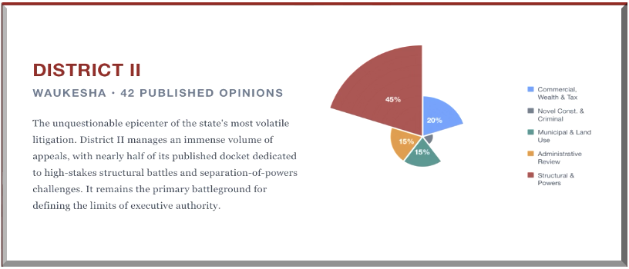

DISTRICT III — WAUSAU
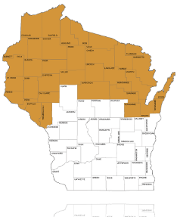
District III, headquartered in Wausau, covers Wisconsin’s northern and central counties. Its docket reflects the region’s character: environmental disputes, property cases, municipal governance, and a steady stream of criminal appeals from rural jurisdictions. During the evaluation period, District III produced 26 published opinions.
Panel Composition
District III operates with a three-judge panel of Presiding Judge Lisa K. Stark, Judge Thomas M. Hruz, and Judge Gregory B. Gill, Jr. This is the only district where the same three judges sit on every case, creating the most cohesive panel in the system.
Analytical Overview
District III produced zero dissents during the entire evaluation period. The three judges agreed on every published opinion—a level of unanimity unmatched by any other district. This cohesion reflects either a shared judicial philosophy, a docket that presents fewer contested questions, or some combination of both.
The quality of District III’s published work is consistently strong. The panel produced several of the evaluation period’s most analytically sophisticated opinions, particularly in areas requiring first-impression statutory interpretation or complex precedent navigation.
Judge Profiles
 | Judge Gregory B. Gill, Jr.  District III—Wausau  Judge Gregory Gill was elected to the Wisconsin Court of Appeals in April 2021 and took the bench that August. His résumé is distinctive for the combination it assembles: front-line prosecution as an Outagamie County Assistant District Attorney beginning in 2003, a federal clerkship with Judge William C. Griesbach of the U.S. District Court for the Eastern District of Wisconsin, private practice at the family firm Gill & Gill, and a decade on the Outagamie County Circuit Court—where he was appointed by Governor Scott Walker in 2011, twice re-elected without opposition, and presided over Mental Health Court and Veterans Treatment Court branches. UW-Madison undergraduate; Marquette University Law School J.D.


Judge Thomas M. Hruz
District III—Wausau
Judge Thomas Hruz was appointed to the Wisconsin Court of Appeals by Governor Scott Walker on July 21, 2014, to succeed retiring Judge Mark Mangerson, and elected without opposition in 2016 and 2022. His credentials read as an appellate-law pedigree: a master's degree in public affairs and public policy analysis from UW-Madison's La Follette School (1997); a J.D. from Marquette University Law School (2002), where he received the Golden Quill Award for best student writing and served as a Marquette Law Review editor; clerkships with Wisconsin Supreme Court Justice David T. Prosser, Jr. (2002-2003) and Judge John L. Coffey of the U.S. Court of Appeals for the Seventh Circuit (2003-2004); and a decade as a partner at Meissner Tierney Fisher & Nichols, S.C. in Milwaukee, where he built an appellate practice. In 2016, Governor Walker named Hruz one of three finalists to replace Justice Prosser on the Wisconsin Supreme Court. Hruz's authored opinions reflect careful textualist methodology and documented judicial restraint. Frankenthal v. West Bend Mutual, an insurance-coverage case, demonstrates the narrow-grounds canon in practice—Hruz explicitly declined to reach broader questions where the case could be resolved on narrower terms.


Judge Lisa Stark
District III—Wausau
Judge Lisa Stark was elected unopposed to the Wisconsin Court of Appeals in April 2013 and, after Governor Scott Walker appointed her to begin her term early, took the bench on April 23, 2013. She was re-elected in 2019 and 2025, and has served as Deputy Chief Judge of the Court of Appeals from 2015 to 2023 and as District III's Presiding Judge since 2015. Before the appellate bench, Stark served 13.5 years on the Eau Claire County Circuit Court (2000-2013) and spent 18 years in private practice as a partner at Misfeldt, Stark, Richie, Wickstrom & Wachs. She has served as Dean of the Wisconsin Judicial College since 2011—having previously held the Associate Dean role from 2005 to 2011—where she oversees Wisconsin's central program of continuing education for new and sitting judges. UW-Eau Claire undergraduate; UW Law School J.D.

Notable Opinions
Outagamie v. MJB (2025 WI App 37).
Judge Stark’s majority holding that the County’s failure to file an examiner’s report forty-eight hours before the final hearing, as required by § 51.20(10)(b), deprives the circuit court of competency to proceed with an involuntary commitment. The opinion’s analytical centerpiece is a comparative statutory analysis: § 51.20(13)(g)2r., which governs recommitment proceedings, explicitly provides that late filing does not affect the court’s jurisdiction—but § 51.20(10)(b), governing initial commitments, contains no such clause.

Rather than treating the omission as an oversight, Stark applied the established canon that the legislature’s silence is intentional when it demonstrably knew how to include the language and chose not to. The opinion departed from the unpublished single-judge decision in Fond du Lac County v. S.N.W., explaining why that case’s reasoning was unpersuasive. Grounded in due process principles—the forty-eight-hour rule is inextricably tied to the subject’s right to two independent examiners, the right to effective counsel, and the right to prepare a meaningful defense against involuntary confinement, which implicates a protected liberty interest
State v. Campbell (2024 WI App 17).
Judge Gill's Fourth Amendment opinion holding that a police canine's two entries into a vehicle through an open driver's side door constituted warrantless searches. Applied the Jones/Jardines trespassory test—the canine, as an instrumentality of law enforcement, physically intruded into a constitutionally protected effect—rather than relying solely on the Katz reasonable-expectation-of-privacy framework. The State asked the court to adopt the "instinct exception" recognized in some other jurisdictions, under which a canine search is constitutional if the canine acts without the handler's direction or encouragement.
Gill exercised exemplary restraint by assuming without deciding whether the exception exists in Wisconsin, then demonstrating it would fail on these facts regardless: the handler maintained full control via a six-foot leash with a pinch collar, positioned his body to block the canine from continuing the exterior scan, stopped at the open door and allowed the canine to enter, made no effort to pull the leash or verbally command the canine to exit during a thirty-eight-second interior search, and then repeated the same sequence a second time.
The opinion surveyed the full landscape of jurisdictions that have adopted the instinct exception—distinguishing Stone (reasonable suspicion present), Winningham (law enforcement created the opportunity), and Guidry (probable cause already established by exterior alert)—and correctly identified the common thread: even jurisdictions that do not require reasonable suspicion still require the government to demonstrate that law enforcement did not facilitate the canine's entry. Unanimous three-judge panel; recommended for publication. Supreme Court review granted.

Oitzinger v. Marinette (2025 WI App 19).
Stark's Open Meetings Law opinion holding that the City of Marinette violated the bargaining exemption under § 19.85(1)(e) by conducting two Council discussions entirely in closed session—one on a PFAS biosolids agreement with Tyco, the other on a consultant's analysis of providing water to the neighboring Town of Peshtigo. Bound by Milton, the opinion reaffirmed that "require" means the government's competitive or bargaining reasons must leave no other option than to close the meeting. Rejected Marinette's proposed "rational justification" standard and multi-factor reasonableness test as grafting words onto the statute the legislature never wrote.

At its first meeting, the Council voted to enter closed session without ever having seen the agreement and without any negotiation strategy to protect—the city's own attorney said negotiations were finished. On the second, the opinion drew a sharp distinction between actual bargaining interests and speculation about future negotiations, noting that the legislature knew how to authorize closure for anticipated events elsewhere in the statute (§ 19.85(1)(g) covers litigation a body "is likely" to face) but chose not to include similar language in the bargaining exemption.

Van Oudenhoven v. DOJ (2024 WI App 38), review dismissed as improvidently granted, 2025 WI 25.

Judge Gill's opinion construing 18 U.S.C. § 921(a)(33)(B)(ii), the "expunged or set aside" exception to the federal firearms prohibition for persons convicted of a misdemeanor crime of domestic violence. Holding: Wisconsin expungement under § 973.015 does not satisfy the federal exception because it "merely deletes the evidence of the underlying conviction from court records"—per State v. Braunschweig, 2018 WI 113—without invalidating the underlying conviction, which remains "an unvacated adjudication of guilt." The DOJ therefore properly denied Van Oudenhoven's 2022 handgun purchase notwithstanding the 2019 expungement of his 1994 misdemeanor battery conviction.

The opinion's analytical architecture is methodical. Gill first established the DOJ's authority as Wisconsin's federally-designated Point of Contact under 28 C.F.R. §§ 25.2 and 25.6(g)(2), resolving Van Oudenhoven's threshold challenge to agency authority. He then construed "expunged or set aside" as a unitary federal term of art requiring complete removal of all effects of the conviction, adopting the reasoning of Wyoming ex rel. Crank v. United States, 539 F.3d 1236 (10th Cir. 2008), and Jennings v. Mukasey, 511 F.3d 894 (9th Cir. 2007). The craft move is the deployment of 18 U.S.C. § 3607—federal controlled-substance expungement, which explicitly restores an offender "to the status he occupied before such arrest or institution of criminal proceedings"—as structural contrast illustrating what a truly effect-removing expungement looks like. Clean textualism, disciplined use of federal out-of-circuit authority, rigorous statutory-structure analysis. Unanimous three-judge panel (Stark, P.J., Hruz, and Gill, JJ.); recommended for publication.

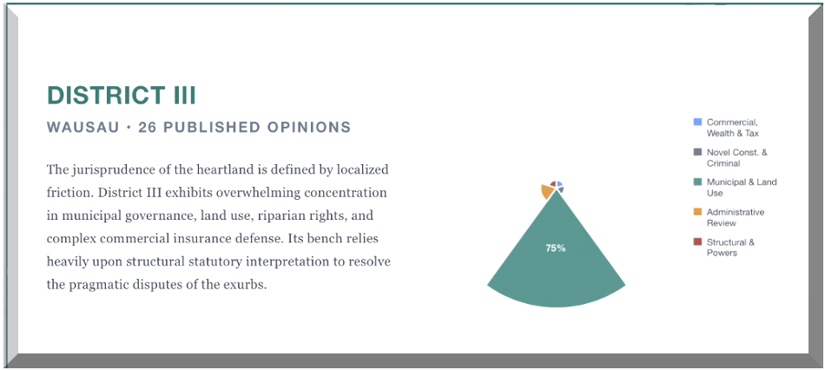

DISTRICT IV — MADISON
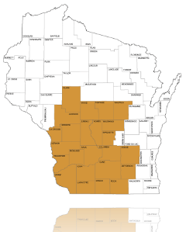
District IV, headquartered in Madison, handles the state’s most significant government-structure disputes by virtue of geography: state agencies, the legislature, and the governor’s office are all located in Dane County, meaning appeals from administrative actions, separation-of-powers disputes, and regulatory challenges disproportionately flow through this district. During the evaluation period, District IV produced 30 published opinions.
Panel Composition
District IV operates with the largest judicial roster of any district: Judges Kloppenburg, Blanchard, Taylor, Graham, and Nashold all sat on panels during the evaluation period. Unlike District III’s fixed three-judge panel, District IV rotates its judges across different three-judge combinations.

Analytical Overview
District IV produced no dissents during the evaluation period—every published opinion was unanimous. This cohesion is notable given the district’s substantively challenging docket. Despite the unanimity, the district drew two significant Supreme Court interactions (see Notable Opinions below).

Judge Profiles

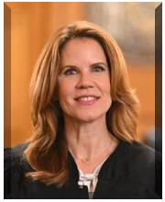
Judge Chris Taylor
District IV—Madison
Judge Taylor was appointed to the Dane County Circuit Court by Governor Evers in 2020—his first judicial appointment—and elected unopposed to the Court of Appeals in 2023, succeeding retiring Judge Michael Fitzpatrick. Before the bench, she served nine years in the Wisconsin State Assembly (2011–2020), including a seat on the Joint Committee on Finance, and earlier served as public policy director for Planned Parenthood of Wisconsin. Her signature authored opinion was Hubbard v. Neuman, construing Wisconsin's informed consent statute, Wis. Stat. § 448.30, to reach physicians who recommend and help plan a procedure even when they do not perform it. Her textual analysis was methodical—consulting Black's, cross-referencing related statutory definitions, and engaging the statute's own exceptions to rebut the defendant's absurd-results arguments. The Supreme Court affirmed 5–2. On April 7, 2026, Taylor was elected to the Wisconsin Supreme Court and will take her seat on August 1, 2026.


Judge JoAnne Kloppenburg
District IV—Madison
Judge Kloppenburg was elected to the Court of Appeals in 2012, following a 23-year career as an Assistant Attorney General at the Wisconsin DOJ (1989–2012)—including a decade as Director of the Environmental Protection Unit—and a clerkship with Chief Judge Barbara Crabb of the Western District of Wisconsin. She was a two-time candidate for the Wisconsin Supreme Court and was re-elected to the Court of Appeals in 2018 and 2024. Kloppenburg authored the most opinions of any District IV judge during the evaluation period (20 of 21 appearances), spanning insurance contract law (Badgerland v. Federated), environmental permitting (Sierra Club v. DNR), constitutional challenges (State v. Wilhite), and criminal procedure (State v. Bell). Her strongest work demonstrates faithful application of binding precedent and careful engagement with the governing statutory framework.


Judge Brian Blanchard
District IV—Madison
Judge Blanchard has served on the Court of Appeals since 2010, elected to the open seat left by Judge Charles Dykman's retirement, and re-elected in 2016 and 2022. Before the appellate bench, he was twice elected Dane County District Attorney (2001–2010), spent seven years as an Assistant U.S. Attorney in the Northern District of Illinois, and clerked for Judge Walter Cummings of the Seventh Circuit. He brings the distinctive pre-law background of six years as a reporter for The Miami Herald. Blanchard participated in the most total opinions of any District IV judge during the evaluation period, with a balanced mix of authored and joined work including Wagner v. Allen Media (defamation), Rise v. WEC (election administration), and Leach v. DFI (securities regulation). He was the only District IV judge to sit on both the Ramirez and Hubbard panels—a signal of his central role in the panel rotation.


Judge Rachel Graham
District IV—Madison
Judge Graham was appointed by Governor Evers in 2019—his first Court of Appeals appointment—to the seat vacated by Judge Gary Sherman, and elected to a full term in 2020. She was named Presiding Judge of District IV in August 2025, succeeding Judge Kloppenburg. Her path to the bench is distinctive: after working as a special education teacher in Baton Rouge, she returned to UW Law and later clerked for Justice Ann Walsh Bradley before eight years in commercial litigation at Quarles & Brady. Graham authored Hanson Trust v. ATC (eminent domain under Wis. Stat. § 32.09) and State v. Schueller (new-factor sentence modification). Her reduced authored output during the evaluation period reflects her increased administrative responsibilities. She also authored the panel opinion in Ramirez that the Supreme Court reversed 5–2 (Justice R.G. Bradley writing for the majority)—the district's most significant Supreme Court correction during the window.

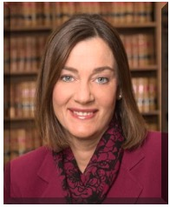
Judge Jennifer Nashold
District IV—Madison
Judge Nashold was elected to the Court of Appeals in 2019 and re-elected unopposed in 2025. Her administrative-law credentials are among the deepest on the court: eight years as an Administrative Law Judge at the Division of Hearings and Appeals (2011–2019); Chief Legal Counsel to the Department of Children and Families; General Counsel to the Public Service Commission; Chairperson of the Wisconsin Tax Appeals Commission; and six years as an Assistant Attorney General at the Wisconsin DOJ. Nashold has the smallest sample size of any District IV judge during the evaluation period, with nine opinion appearances. She authored Birge v. Simplicity (consumer protection / statute of frauds). Her limited portfolio makes broad methodological characterization difficult, but her administrative-law pedigree makes her a natural authority on the district's agency-review caseload.

Notable Opinions
State v. Ramirez (2024 WI App 28), rev’d, (2025 WI 28).
The Court of Appeals (Graham, J., joined by Kloppenburg, J., and Blanchard, J.) held that the defendant’s constitutional speedy trial right was violated under the Barker v. Wingo four-factor test, finding the 46-month pretrial delay—the longest in any published Wisconsin speedy trial case since Barker—required dismissal. Over 31 months were attributable to the State, driven by unexplained scheduling gaps, courtroom double-bookings, prosecutor retirement, and witness unavailability. The circuit court’s finding that delay was caused by the defendant’s discovery requests was clearly erroneous; surveillance footage the prosecution called “mythical” had in fact existed. The Supreme Court reversed 5-2 (R.G. Bradley, J.), concluding the Court of Appeals erred in weighing the first Barker factor as independently “heavy” against the State before fully analyzing the remaining factors and in overturning the circuit court’s factual findings.
Hubbard v. Neuman (2024 WI App 22) (affirmed, 2025 WI 15)
The Court of Appeals (Taylor, J., joined by Blanchard and Graham, JJ.) affirmed the circuit court's denial of a physician's motion to dismiss an informed consent claim under Wis. Stat. § 448.30. The court held that the duty to inform applies to "any physician who treats a patient," not only to the physician who performs the surgery, and that the complaint sufficiently alleged Dr. Neuman was a treating physician—she diagnosed Hubbard's endometriosis, engaged in presurgery planning, and recommended to the operating surgeon that he remove Hubbard's ovaries, all without informing Hubbard. The court also affirmed denial of summary judgment, finding Dr. Neuman failed to make a prima facie case on causation. The Supreme Court affirmed 5-2 (A.W. Bradley, C.J.), holding the complaint alleged sufficient facts to survive dismissal. Justice Ziegler, joined by Justice R.G. Bradley, dissented, arguing the majority interpreted "physician who treats" too broadly and failed to adequately define who qualifies as a treating physician under § 448.30.
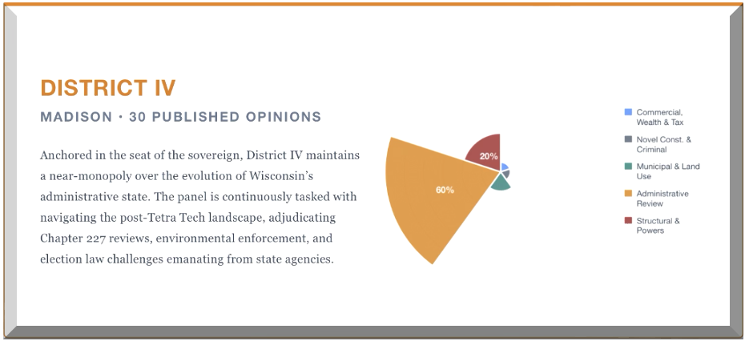

SUPREME COURT INTERACTIONS
The Wisconsin Supreme Court’s review of Court of Appeals opinions provides an external check on appellate quality. During the evaluation period, several Court of Appeals opinions were reviewed by the Supreme Court, with outcomes ranging from affirmance to unanimous reversal.
District II: The Most Reversals
District II produced the most Supreme Court reversals of any district. The Kaul v. Legislature unanimous reversal (7-0), the WMC v. DNR reversal (5-2), the Halter v. WIAA reversal (5-2), and the Oconomowoc v. Cota reversal (5-2) collectively represent a significant institutional correction of District II’s approach to statutory interpretation and separation-of-powers questions. In each case, Judge Neubauer had dissented from the Court of Appeals majority—a pattern that warrants close attention as District II’s composition evolves.
District IV: Contested Affirmance and Reversal
District IV’s Ramirez reversal (5-2, with Justice Grassl Bradley writing for the majority) and the contested Hubbard affirmance (5-2, with Justices Ziegler and Grassl Bradley dissenting) reflect ongoing doctrinal disagreement at the Supreme Court level, particularly on criminal procedure and statutory expansion questions.
District I: One Procedural Reversal
The State v. J.D.B. reversal (6-1) was the only significant Supreme Court correction of a District I opinion. The reversal addressed procedural requirements for involuntary medication orders rather than a fundamental methodological disagreement.
District III: No Completed Reversals
District III had no completed Supreme Court reversals during the evaluation period, though Outagamie v. MJB is pending review. The absence of reversals may reflect the district’s cohesive methodology, its smaller and less politically charged docket, or simply the Supreme Court’s limited bandwidth.

LOOKING AHEAD
The 2024–2025 evaluation period provides a baseline for ongoing assessment of Wisconsin’s Court of Appeals. Several developments will shape the next evaluation cycle:

Pending Supreme Court reviews of Outagamie v. MJB (District III) and SG v. WI DCF (District IV) may produce additional corrections that affect the evaluation of those districts’ analytical approaches.

Structural reform of the Court of Appeals remains a priority. The geographic case concentration, the absence of statewide panel randomization, and the first-to-publish binding precedent rule all warrant legislative attention. IRG’s Structural Reform of Judicial Selection in Wisconsin provides a comprehensive framework for these reforms.

IRG’s Court Watch Program will continue to monitor and evaluate the Court of Appeals on an ongoing basis, with annual reviews of published opinions and Supreme Court interactions.

ReformingGovernment.org
PO Box 180291 | Delafield, WI 53018 | info@reforminggovernment.org

APPENDIX I: OPINIONS ANALYZED

This appendix lists all published Wisconsin Court of Appeals opinions from January 1, 2024 - December 31, 2025.
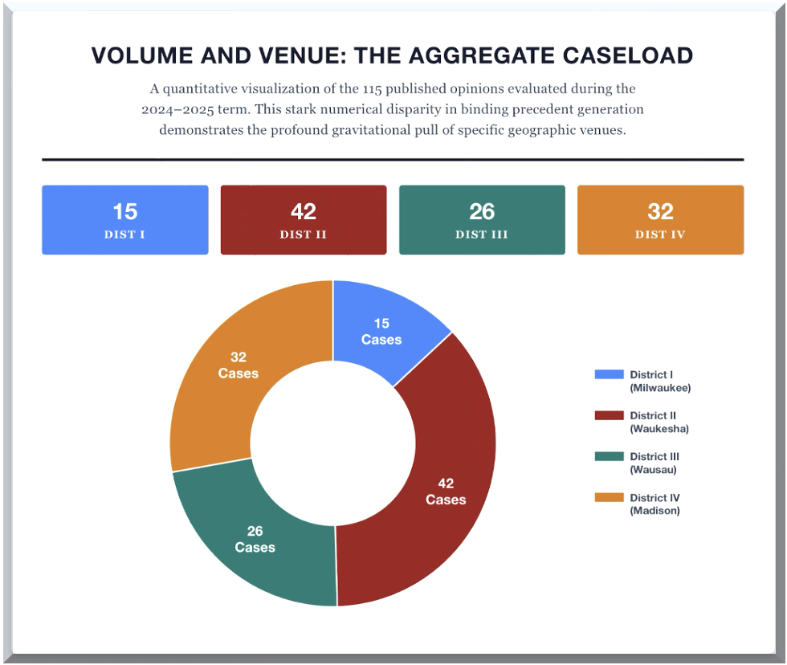

District I — Milwaukee (15 opinions)
Operating under an aggressive publication filter, District I’s authorship is heavily weighted toward complex commercial disputes and novel constitutional procedure, with Judge Geenen serving as the panel's primary authorial voice.
Citation | Case Name | Author | Area of Law
2024 WI App 33 | Lorbiecki v. Pabst | White | Property / Punitive Damages
2024 WI App 44 | State v. Adams | Geenen | Criminal Procedure / Juvenile Law
2024 WI App 46 | Hess v. WEC | Colón | Election Law
2024 WI App 50 | State v. Robinson | White | Criminal Procedure / Sixth Amendment
2024 WI App 69 | Cottage Food v. DATCP | Colón | Administrative Law
2025 WI App 5 | State v. J.D.B. | Geenen | Criminal Procedure / Due Process
2025 WI App 17 | Bank of Am. v. Riffard | White | Civil Law
2025 WI App 22 | Wren v. Columbia St. Mary’s | Colón | Civil Law
2025 WI App 29 | Miller Compressing v. Busby | Geenen | Administrative Law
2025 WI App 30 | Freeman v. SL Greenfield | Geenen | Civil Law
2025 WI App 43 | Children’s Hosp. v. Wauwatosa | Colón | Property / Tax Exemption
2025 WI App 55 | Midwest Envt. Advocs. v. Prehn | Geenen | Administrative / Environmental Law
2025 WI App 60 | State v. Kenyon | Geenen | Criminal Procedure
2025 WI App 63 | Friends of Blue Mound v. DNR | Colón | Administrative / Environmental Law
2025 WI App 66 | State v. Shallcross | Geenen | Criminal Procedure

District II (Waukesha)
The epicenter of Wisconsin’s structural litigation. District II presents an immense volume of consequential opinions, showcasing sharp methodological divides—particularly between Judge Neubauer and the panel majority—on questions of executive authority and statutory interpretation.

Citation | Case Name | Author | Area of Law
2022AP1909 | WI DOR v. Masters Gallery Foods | Neubauer | Property / Tax Law
2023AP588 | Cincinnati Ins. v. Ropicky | Grogan | Insurance / Contract
2023AP614 | Eddings v. Estate of Young | Gundrum | Civil Tort
2023AP970CR | State v. Dachelet | Per Curiam/Panel | Criminal Procedure
2024 WI App 8 | Oconomowoc Area SD v. Cota | Gundrum | Employment Discrimination
2024 WI App 12 | Halter v. WIAA | Lazar | Civil / Voluntary Association Rules
2024 WI App 18 | WMC v. DNR | Grogan | Administrative / Environmental Law
2024 WI App 23 | WMC v. Village of Pewaukee | Lazar | Municipal / Administrative Law
2024 WI App 30 | McLaughlin v. Gaslight Pointe | Neubauer | Insurance / Contract
2024 WI App 31 | State v. Larson | Gundrum | Criminal Procedure
2024 WI App 35 | State v. West | Grogan | Criminal Procedure
2024 WI App 39 | Morgan v. LIRC | Neubauer | Administrative / Employment Law
2024 WI App 42 | Braun v. Vote.org | Grogan | Election Law
2024 WI App 53 | Freude v. DiRenzo | Neubauer | Legal Malpractice
2024 WI App 54 | Fish v. Bevco (LIRC) | Neubauer | Administrative Law
2024 WI App 57 | Danielson v. Danielson | Gundrum | Family Law
2024 WI App 60 | Eddings v. Estate of Young (2024) | Gundrum | Civil Tort
2024 WI App 64 | Rose v. Rose | Per Curiam/Panel | Family Law
2024 WI App 72 | State v. Gasper | Neubauer | Criminal Procedure
2024AP742 | Doubleday v. Goeman Properties | Per Curiam/Panel | Property Law
2024AP1098 | Somerset Condo v. RC Somerset | Neubauer | Property / Contract
2025 WI App 2 | Legislature v. Kaul (§165.10) | Lazar | Separation of Powers
2025 WI App 3 | Kaul v. Legislature (§165.08) | Lazar | Separation of Powers
2025 WI App 6 | State v. Joling | Grogan | Criminal Procedure
2025 WI App 12 | Garrett v. Ocean View Swimming Pool | Gundrum | Civil Tort
2025 WI App 13 | Scudder v. Concordia University | Lazar | Civil Procedure
2025 WI App 14 | Radtke v. LIRC | Neubauer | Administrative Law
2025 WI App 16 | Wied v. Wheeler | Gundrum | Municipal Law
2025 WI App 21 | US Cellular v. Fond du Lac County | Grogan | Municipal / Administrative Law
2025 WI App 24 | Rabiebna v. HEAB | Gundrum | Constitutional Law / Equal Protection
2025 WI App 25 | State v. Solom | Lazar | Criminal Procedure
2025 WI App 27 | DRW/LWV v. WEC | Gundrum | Election Law
2025 WI App 36 | State v. Rejholec | Neubauer | Criminal Procedure
2025 WI App 42 | State v. Dachelet (2025) | Gundrum | Criminal Procedure
2025 WI App 47 | Wildwood Estate v. Village of Summit | Gundrum | Property / Due Process
2025 WI App 49 | WRA v. City of Neenah | Lazar | Municipal Law / Statutory Preemption
2025 WI App 50 | Abby Windows v. LIRC | Grogan | Administrative Law
2025 WI App 61 | Bank of America v. Estate of Nelson | Neubauer | Property / Foreclosure
2025 WI App 67 | State v. Joski | Gundrum | Criminal Procedure
2025 WI App 73 | State v. Syrrakos | Neubauer | Criminal Procedure
2025 WI App 74 | State v. Petersen | Neubauer | Criminal Procedure
2025AP1745 | State v. B.M.T. | Lazar | Criminal Procedure

District III (Wausau)
The most cohesive panel in Wisconsin jurisprudence. Operating without a single dissent, Judges Stark, Hruz, and Gill collectively navigated a docket deeply embedded in localized, pragmatic disputes spanning municipal governance, land use, and complex commercial insurance.

Citation | Case Name | Author | Area of Law
2021AP1596 | State v. Young | Hruz | Criminal Procedure
2022AP2222 | State v. Minck | Hruz | Criminal Procedure
2023AP1475 | OptumRx v. Marinette | Hruz | Contract
2023AP1697 | Miller v. West Bend | Stark | Insurance
2023AP1747 | State v. Schaefer | Gill | Criminal Procedure
2023AP2135 | Dizard v. Torro | Gill | Contract
2024 WI App 3 | Ricciardi v. Town of Lake | Stark | Property / Inverse Condemnation
2024 WI App 13 | State v. Gomolla | Stark | Criminal Procedure
2024 WI App 17 | State v. Campbell | Gill | Criminal Procedure / Fourth Amendment
2024 WI App 19 | Bolger v. MBIC | Gill | Insurance
2024 WI App 26 | Koble v. Marquardt | Gill | Consumer Law
2024 WI App 27 | State v. Vannieuwenhoven | Gill | Criminal Procedure / Fourth Amendment
2024 WI App 38 | Van Oudenhoven v. DOJ | Stark | Statutory Interpretation
2024 WI App 51 | State v. Hill | Stark | Criminal Procedure
2024 WI App 52 | Sierra Club v. PSC | Gill | Administrative Law
2024 WI App 58 | Balsimo v. Venture One Stop | Hruz | Contract
2024 WI App 59 | Kaiser v. Townline | Hruz | Probate
2024 WI App 66 | Miller v. West Bend (2) | Stark | Insurance
2024 WI App 71 | Frankenthal v. West Bend | Hruz | Insurance
2024 WI App 73 | St. Croix v. Osceola | Gill | Statutory Interpretation / Land Use
2025 WI App 4 | Frey v. Hasheider | Gill | Civil Tort
2025 WI App 19 | Oitzinger v. Marinette | Stark | Administrative Law
2025 WI App 37 | Outagamie v. MJB | Stark | Mental Health Law
2025 WI App 38 | Prunty v. Maple Valley | Stark | Insurance
2025 WI App 68 | Stone v. WEC | Stark | Election Law
2025 WI App 69 | S.S. v. A.S.-P. | Stark | Family Law

District IV (Madison)
Anchored in the seat of the sovereign, District IV maintains a near-monopoly on the review of executive agency actions. The district's five jurists consistently apply methodical, text-bound analysis to the state's most complex regulatory and administrative challenges.

Citation | Case Name | Author | Area of Law
2023AP1133 | Leach v. DFI | Nashold | Administrative Law / Securities
2023AP1755-CR | State v. Schueller | Graham | Criminal Procedure
2024 WI App 4 | State v. VanderGalien | Kloppenburg | Criminal Procedure
2024 WI App 9 | Wagner v. Allen Media | Graham | Civil Tort / Defamation
2024 WI App 11 | State v. M.L.J.N.L. | Graham | Criminal Law
2024 WI App 14 | Mitchell v. Buesgen | Blanchard | Civil Law / Administrative
2024 WI App 15 | Laughing Cow v. DOR | Graham | Administrative Law / Tax
2024 WI App 22 | Hubbard v. Neuman | Taylor | Civil Tort / Medical Malpractice
2024 WI App 24 | Ripp v. Ruby | Graham | Contract / Commercial Law
2024 WI App 28 | State v. Ramirez | Graham | Criminal Procedure
2024 WI App 34 | Midwest Renewable Energy v. PSC | Taylor | Administrative Law / Utility Regulation
2024 WI App 36 | Badgerland v. Federated Mutual | Kloppenburg | Civil Law / Insurance
2024 WI App 43 | Savich v. Columbia County | Blanchard | Administrative Law / Property
2024 WI App 45 | State v. Kruckenberg Anderson | Taylor | Criminal Procedure
2024 WI App 47 | Buchholz v. Schmidt | Kloppenburg | Property / Contract / Nuisance
2024 WI App 48 | Rise v. WEC | Taylor | Election / Administrative Law
2024 WI App 55 | Hanson Trust v. ATC | Graham | Property / Eminent Domain
2024AP777-CR | State v. Phelan | Blanchard | Criminal Law
2024AP1091 | Dyersville Ready Mix v. Iowa County | Blanchard | Administrative Law / Property Zoning
2024AP1233 | Gonfiantini v. Rock County | Graham | Election Law
2024AP1725 | Dwyer v. City of Monona | Blanchard | Administrative / Civil Law
2024AP2177-CR | State v. Wilhite | Kloppenburg | Criminal Procedure / Constitutional Law
2025 WI App 7 | State v. Coleman | Graham | Criminal Procedure
2025 WI App 8 | Kraemer v. Traun | Graham | Property Law / Civil Procedure
2025 WI App 9 | State v. D.E.C. | Blanchard | Criminal Law
2025 WI App 18 | MPI Wright v. Goodin | Taylor | Contract / Property
2025 WI App 32 | S.G. v. WI DCF | Taylor | Administrative Law / Family Law
2025 WI App 39 | Sierra Club v. DNR | Kloppenburg | Administrative / Environmental Law
2025 WI App 62 | Birge v. Simplicity CU | Nashold | Contract / Consumer Law
2025 WI App 75 | State v. Bell | Kloppenburg | Criminal Procedure

APPENDIX II: APPELLATE COURT REFERENCE GUIDE
Institutional Context
The Wisconsin Court of Appeals is primarily an error-correction court. Its published opinions are binding precedent across all four districts until overruled by the Wisconsin Supreme Court. Cook v. Cook, 208 Wis. 2d 166, 188 (1997). The Supreme Court has recognized that published Court of Appeals opinions serve a “law defining and law development” function. The Court issues a written decision in every case. A Publication Committee determines which opinions are published and citable as precedential authority under Wis. Stat. § 809.23. Opinion assignment is by lot.
A. Standards of Review
Standard | Applies To | What the Appellate Court Does | Authority
Clearly Erroneous | Findings of fact (bench trial) | Upholds the finding unless no credible evidence supports it. Does not reweigh evidence or reassess credibility. | § 805.17(2)
Any Credible Evidence | Jury verdicts | Searches for any credible evidence supporting the verdict returned. Does not consider evidence supporting a verdict not reached. | Common law
De Novo | Questions of law | Reviews independently, no deference to circuit court’s legal analysis. | Common law
Erroneous Exercise of Discretion | Discretionary determinations | Upholds if circuit court applied the correct legal standard to relevant facts and reached a reasonable conclusion. | Common law
Two-Step (Mixed) | Mixed fact and law | Step 1: factual findings under clearly-erroneous. Step 2: application of law to facts de novo. | Common law

B. Statutory Interpretation: The Kalal Framework
State ex rel. Kalal v. Circuit Court, 2004 WI 58, ¶45: Begin with the statutory language. If the meaning is plain, stop and apply. Only if the text is ambiguous may the court consult extrinsic sources. The ambiguity gateway is the structural feature: extrinsic sources are permissible only after a threshold finding of ambiguity.
C. Administrative Deference: The Tetra Tech Framework
Tetra Tech EC, Inc. v. DOR, 2018 WI 75, eliminated Chevron-style deference in Wisconsin. Courts review agency legal conclusions de novo. Permissible under § 227.57(10): acknowledging agency technical expertise as an input to the court’s own independent analysis. Impermissible: treating the agency’s legal interpretation as presumptively correct.

D. Precedent Hierarchy

➢ SCOW opinions bind all lower courts.
➢ Published CoA opinions bind all districts under Cook v. Cook, 208 Wis. 2d 166 (1997).
➢ Unpublished opinions after July 1, 2009, authored by a panel member, may be cited for persuasive value only. § 809.23(3)(b).
➢ CoA panels cannot overrule SCOW. Legitimate channels: concurrence/dissent inviting reconsideration, or certification under § 809.61.
➢ On federal-law questions, U.S. Supreme Court controls under the Supremacy Clause.

E. Constitutional Avoidance
Courts must decide on statutory or sub-constitutional grounds when available and adequately briefed before reaching a constitutional question.

F. Presumption of Constitutionality and Burden of Proof
A party challenging a statute’s constitutionality must prove it unconstitutional beyond a reasonable doubt. Every presumption is indulged to sustain the law. Doubt is resolved in favor of constitutionality. Appling v. Walker, 2014 WI 96, ¶17; State v. Cole, 2003 WI 112, ¶11. In a hybrid challenge, the challenger must show that as to the specific category of applications, the statute could not be constitutionally enforced under any circumstances. SEIU v. Vos, 2020 WI 67, ¶45.
This burden is not a formality. It allocates the risk of uncertainty to the challenger and establishes that the defender of the statute need not justify every application—the challenger must negate every application. A judge who states this burden but then analytically requires the statute’s defender to justify its constitutionality has inverted the burden even while reciting the correct standard.

G. Holding vs. Dicta in Controlling Precedent
The holding of a case is the rule of law necessary to the disposition of the specific issue before the court. Dicta is everything else—observations, illustrations, hypotheticals, and statements about issues the court did not need to resolve. A footnote in a majority opinion may be holding or dicta depending on whether it resolves an issue necessary to the disposition. A concurrence or dissent is never holding. An explicit reservation of a question (“we express no opinion on X”) is the court’s declaration that X is not part of its holding.When reading a controlling case, a CoA judge must distinguish what the court held from what it said. Reliance on dicta is permissible for persuasive guidance but cannot be treated as controlling. Reliance on a dissent as though it were the majority’s holding is a hierarchy error. And treating an explicitly reserved question as though the court resolved it is a misreading of the precedent.

Wisconsin Appellate Court Glossary —> we could also include this or something similar as a third appendix but I know we’re running long already)

On February 25, 2026, SCOW reversed 6–1, upholding the circuit court's involuntary medication order. Hagedorn, J., for the majority (joined by Karofsky, C.J., Ziegler, R.G. Bradley, Dallet, and Protasiewicz, JJ.), held that Sell Factor 1 (important governmental interest) is reviewed de novo, while Factors 2–4 are reviewed for clear error; applied under that framework, Factor 1 was satisfied notwithstanding defendant's pretrial confinement and potential civil commitment, and the circuit court's findings on Factors 2–4 and Wis. Stat. § 971.14(3)(dm)–(4)(b) were not clearly erroneous. The Court also overruled State v. Green, 2021 WI App 18, to the extent it had been read to mandate a fixed evidentiary checklist (specific meds, dosages, weight, cognitive ability, etc.), holding that Sell requires individualized findings but permits flexibility in the supporting evidence. Crawford, J., dissented, concluding that approximately eight months of pretrial confinement and the likelihood of civil commitment diminished the State's Factor 1 interest below the constitutional threshold.
On April 15, 2026, SCOW affirmed the panel's safe-place and punitive-damages analyses but reversed on the § 895.043(6) cap (5–2), adopting the narrower reading that "compensatory damages recovered" means only amounts legally recoverable against the remaining defendant. Punitive damages capped at $4,657,937.38; final judgment $6,986,906.07. Ziegler, J., dissented (joined by R.G. Bradley, J.); Dallet, J., concurred separately (joined by Hagedorn, J.) on the unresolved summary-judgment-review-record question.
The 4-justice majority in Brown v. WEC, 2025 WI 5, ¶24, expressly overruled Hess "to the extent that it holds any complainant whose complaint is dismissed is aggrieved under § 5.06(8)." Karofsky, C.J., wrote for the majority, joined by Ann Walsh Bradley, Dallet, and Protasiewicz, JJ. Justice R.G. Bradley's dissent (joined on this point by Chief Justice Ziegler, and as to ¶¶28–43 by Justice Hagedorn) quoted Hess ¶18 at length in defending the plain-text reading against the majority. Hess's substantial compliance analysis under Wis. Stat. § 8.15, which is not addressed in Brown, remains good law.
Oconomowoc Area Sch. Dist. v. Cota, 2025 WI 11 (reversing 5-2; Dallet, A.W. Bradley, Hagedorn, Karofsky, Protasiewicz for the majority; R.G. Bradley and Ziegler dissenting). The Wisconsin Supreme Court adopted Neubauer's plain-text reading that "any other offense" includes non-criminal offenses, and rejected both the majority's limiting construction and Grogan's practical-consequences reductio.
Review granted. Oral argument held March 11, 2026; decision pending as of this report.
Kaul v. Wis. State Legislature, 2025 WI 23 (reversing 7-0; Hagedorn, J., for a unanimous court). The court held that the JFC-approval requirement violates the separation of powers as applied to civil enforcement settlements, finding the majority had overstated SEIU v. Vos, 2020 WI 67, which had merely rejected a facial challenge to § 165.08(1).
Bypass petition denied. The case returns to circuit court on the merits; no petition for review of the Court of Appeals disposition was filed.
Review granted November 11, 2025. Oral argument scheduled; decision pending.
Review granted; oral argument held February 10, 2026; decision pending. If the Wisconsin Supreme Court's analysis focuses on the Fungi Exclusion framework, the opinion could carry further doctrinal consequences for the district.
Petition for review filed by LIRC on September 19, 2024; disposition pending as of this report
Wis. Mfrs. & Commerce v. DNR, 2025 WI 26 (reversing 5-2; Protasiewicz, J., for the majority; R.G. Bradley and Ziegler dissenting). The court vindicated Neubauer's reading of § 292.01(5), holding that the statute's broad definition of "hazardous substance" supports case-by-case enforcement. The reversal preserved environmental enforcement authority for Wisconsin communities facing PFAS contamination.
On June 24, 2025, SCOW dismissed review as improvidently granted, 4-3, leaving Judge Gill's opinion untouched and fully binding as statewide precedent. Per curiam majority: A.W. Bradley, C.J., Dallet, Protasiewicz, and Karofsky, JJ. Dallet, J., concurred separately (joined by A.W. Bradley, C.J., and Protasiewicz, J.), urging that the court should explain its DIG dispositions and suggesting, without elaboration or record citation, that "this case may not squarely raise [the] issue" on which review was granted. Ziegler, J., dissented (joined by R.G. Bradley, J.), arguing the issue was squarely presented, the DOJ had expressly disclaimed at oral argument any challenge to the 2019 expunction order's validity, and the question—on which neither SCOW nor SCOTUS has spoken authoritatively—is one of statewide importance on which the Court had a duty to rule. Hagedorn, J., dissented separately in a one-paragraph opinion: "This case presents a question of statutory interpretation perfectly fitting for this court's decision, and we should answer it."
State v. Ramirez, 2025 WI 28 (reversing the Court of Appeals and holding that the first Barker factor cannot be weighed as independently "heavy" against the State before the remaining factors are analyzed; further holding that the Court of Appeals improperly disturbed the circuit court's factual findings on delay attribution).
Wisconsin Supreme Court Office of the Clerk, 2023–2024 Term Annual Report (noting that the Supreme Court "grants review of fewer than ten percent of the petitions of review" filed; during the 2023–24 term, 11 of 569 petitions disposed of were granted).
Wis. Stat. § 809.61 (Rule) ("The supreme court may take jurisdiction of an appeal or other proceeding in the court of appeals upon certification by the court of appeals or upon the supreme court's own motion. The supreme court may refuse to take jurisdiction of an appeal or other proceeding certified to it by the court of appeals.").
Tetra Tech EC, Inc. v. Wisconsin Department of Revenue, 2018 WI 75 (ending judicial deference to agency legal interpretations and restoring de novo review).
State ex rel. Kalal v. Circuit Court for Dane County, 2004 WI 58 (establishing the plain-meaning framework and three-step analytical sequence for Wisconsin statutory interpretation).
Cook, supra, at ¶ 54.
Cook v. Cook, 208 Wis. 2d 166, ¶¶ 50-54, (1997) (holding that the Court of Appeals lacks authority to overrule its own published decisions and must either certify the appeal to the Supreme Court or adhere to the prior opinion while explaining its disagreement); see also Wisconsin Voter Alliance v. Secord, 2025 WI 2 (reversing the Court of Appeals for a "patent violation" of Cook and reaffirming the certification-or-adhere framework).
See, e.g., United States v. Jones, 565 U.S. 400 (2012), and Florida v. Jardines, 569 U.S. 1 (2013) (Fourth Amendment search doctrine); Katz v. United States, 389 U.S. 347 (1967) (reasonable expectation of privacy); Miranda v. Arizona, 384 U.S. 436 (1966), and its progeny (Fifth Amendment self-incrimination); Strickland v. Washington, 466 U.S. 668 (1984) (Sixth Amendment effective assistance of counsel); Barker v. Wingo, 407 U.S. 514 (1972) (Sixth Amendment speedy trial); State v. Knapp, 2005 WI 127 (Wisconsin Constitution's independent protection against self-incrimination).
See Wis. Stat. § 809.23(1)(a) (Rule) (establishing criteria for publication of Court of Appeals opinions, including whether the opinion decides a novel question of law, modifies or clarifies an existing rule, or applies an established rule in a significantly different factual context).
See Barker, supra note 7.
Hubbard v. Neuman, 2025 WI 15 (affirming the Court of Appeals and holding that the complaint alleged sufficient facts to survive dismissal under Wis. Stat. § 448.30; Ziegler, J., joined by R.G. Bradley, J., dissenting on grounds that the majority's interpretation of "physician who treats" was impermissibly broad).
State v. Kleser, 328 Wis. 2d 42 (2010) (defining the scope of juvenile preliminary examinations under Wis. Stat. § 970.032 and affording limited latitude to challenge the charged jurisdictional offense).

